**Do Now**

Name: ______________

Date: ______________

**Directions:** Read the following poems and then answer the questions.

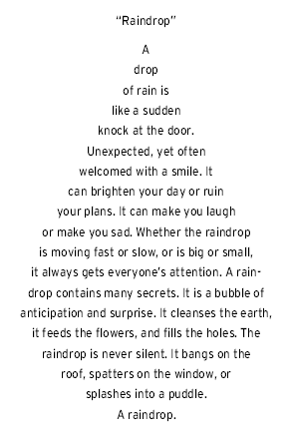

1. What is this poem about?
2. What shape(s) are in this poem?
3. How do they relate to the topic of the poem?
4. What is this poem about?
5. What shape(s) are in this poem?
6. How do they relate to the topic of the poem?

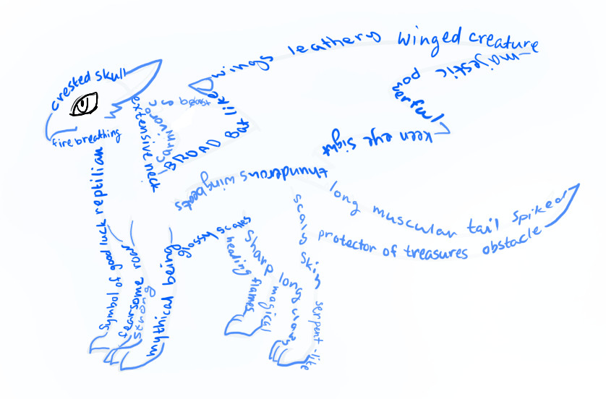

**Notes**

Name: ______________

Date: ______________

***Concrete Poems***

|  |  |
| --- | --- |
| Questions & Key Words | Details |
| What is a **concrete poem**? | * A concrete poem is one that takes the shape of what it’s describing. * It is often called visual poetry or shape poetry. * The arrangement of the letters and words are important to the overall meaning and message of the poem. |

Check this out ☺ Now, the same poem as a ***Concrete Poem***:

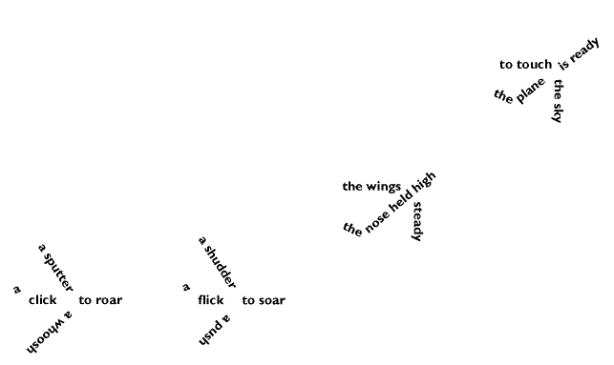

**Original poem:**

A sputter, a click,

A whoosh to roar,

A shudder, a flick,

A push to soar,

The wings steady,

The nose held high,

The plane is ready,

To touch the sky.

* How is the original version of the poem different from the *concrete poetry* version?

_________________________________________________________________________

* How is the experience of reading the first poem different from the experience of reading the second version of the poem?

_________________________________________________________________________

_________________________________________________________________________

* What shape does the concrete poem take? How does the shape help convey the poem’s message?

_________________________________________________________________________

**Classwork**

Name: ____________

Date: ____________

**Directions:** Read the poems and answer the questions on the back!

**The Mouse's Tale**

*by Lewis Carroll*

Fury said to a mouse,

That he met in the

house, “Let us

both go to law:

I will prosecute

you.- Come, I'll

take no denial;

We must have

a trial: For

really this

morning I've

nothing to do.”

Said the mouse

to the cur,

“Such a trial,

dear Sir, With

no jury or

judge, would

be wasting

our breath.”

“I'll be

judge, I'll

be jury,”

Said cunning

old Fury:

“I'll try

the whole

cause, and

condemn

you

to

death.”

**3**

**1**



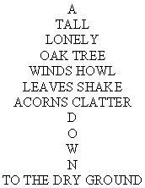

**2**

**From way                                                                                                                          sky.  
        back here                                                                                                                     the   
            down                                                                                                                      touch  
              through                                                                                                            feet  
                   the                                                                                                            my   
                      air                                                                                                    where  
                          down                                                                                          to   
                               down                                                                               I fly                
                                  I  rush                                                                       up  
                                          to                                                                 up  
                                               way                                                again  
                                                        down                             up  
                                                                      there,   then**

**4**

**Questions about concrete poems on opposite page:**

1. Topic of the poem: ____________________________

* What does this poet do with certain words that is very unusual?

_____________________________________________________________________

_____________________________________________________________________

2. Topic of the poem: ____________________________

* One word is written differently from all the others. What word is it and why is it written this way?

_____________________________________________________________________

_____________________________________________________________________

3. Topic of the poem: ____________________________

* What is the double meaning of the title of this poem?

_____________________________________________________________________

_____________________________________________________________________

4. Topic of the poem: ____________________________

* How does this poem make your *eyes* EXPERIENCE what the poem is about?

_____________________________________________________________________

_____________________________________________________________________

**Classwork**

Name: ____________

Date: ____________

**Concrete Poem Paragraph Analysis!**

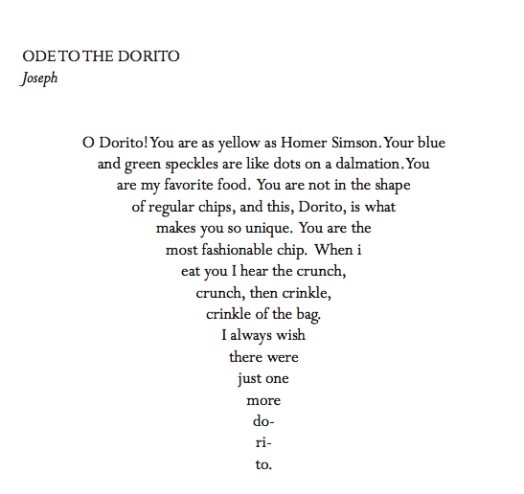

Directions: Read the poem and complete a paragraph analysis.

**Paragraph Analysis: Remember…COMPLETE SENTENCES!**

Topic Sentence (title, author, meaning): ____________________________________________________________________________

____________________________________________________________________________

2 poetic devices the author uses, example, and meaning:

____________________________________________________________________________

____________________________________________________________________________

____________________________________________________________________________

____________________________________________________________________________

____________________________________________________________________________

Is the poem a specific form? (ode, elegy, concrete poem…):

____________________________________________________________________________

Conclusion Sentence (summarize your points):

____________________________________________________________________________

____________________________________________________________________________

**Classwork**

Name: ____________

Date: ____________

**Create your own concrete poems.**

The only requirements for these poems are that you must use IMAGERY and each poem must be in the FORM OF ITS SUBJECT!